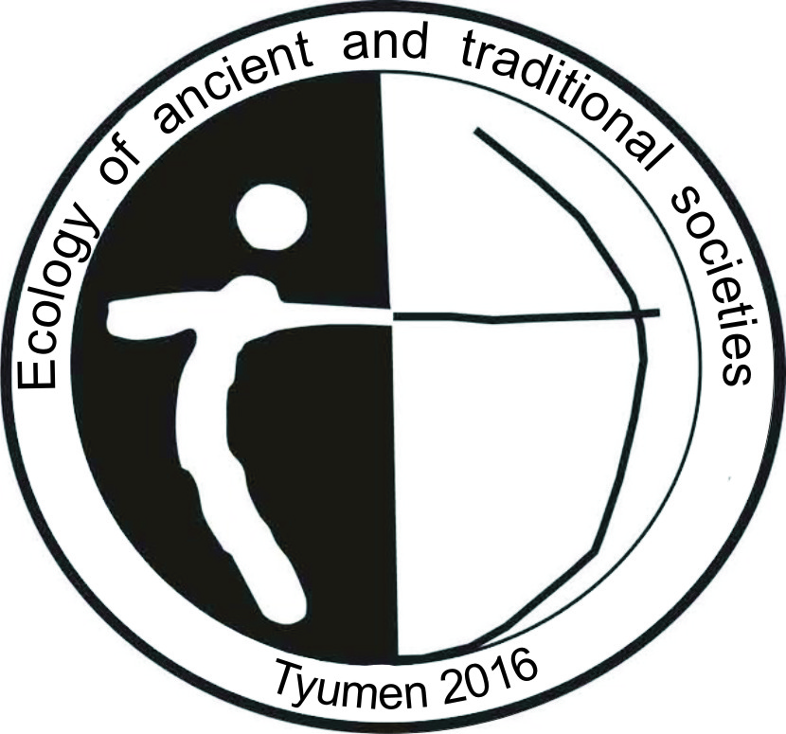
The fifth international scientific conference
«Ecology of ancient and traditional societies»
First letter of invitation

Dear colleagues,
Tyumen State University, Institute of problems of development of the North, SB RAS (Tyumen) and the Institute of Plants and Animalsecology, UB RAS (Yekaterinburg) invite you to our regular conference «Ecology of ancient and traditional societies», which will be held in November 2016 in Tyumen, Russia.
The meeting will consist of four main themes (sections):
1. Historical human ecology (S. Slepchenko)
2. Reconstruction of natural environment and life-support systems of ancient and medieval peoples (N. Ryabogina, A. Yakimov)
3. Ecological anthropology (V. Adaev)
4. Cultural landscapes (S. Kozlov)
The EATS conference aims at bringing together researchers working on problems of human ecological adaptation from different perspectives. We expect to pay special attention to interdisciplinary research methods, revealing the process of interaction between man, nature and society in a broad chronological framework, to share results of studies of natural changes and catastrophes, variations in adaptation strategies, the cultural components of human impact on the natural environment, and practice of landscape transformation by human populations in different epochs.
The Cultural program of the EATS conference suggests visiting the local famous historical sites: The old parts of Tyumen (the first Russian Siberian city), The Rasputin Museum at Pokrovskoye and the Tobolsk Kremlin.
Pre-registration deadline (see form 1) – 1 September 2015; paper submission – 15 April 2016.
If you have any questions, please, ask for help: ecologia-2016@mail.ru
Executive secretary of Conference Committee:
Irina Chikunova (3452) 688-763 chikki@mail.ru
Conference committee
MatveevaN.P., professor of the Department of Archaeology, Ancient and Medieval History, headof the Laboratoryof archaeology and ethnology,Institute of History and Political Sciences, Tyumen State University (Tyumen), convener of committee.
BagashevA.N., director of the Institute of problems of development of the North, SB RAS (Tyumen), co-convener of committee.
Buzhilova A.P., corresponding member of RAS, director of the Institute of Anthropology, Moscow State University (Moscow).
MolodinV.I.,member of RAS, deputy director of the Institute of Archaeology and Ethnography, SB RAS (Novosibirsk).
TolstikovA.V., vice rector for research of the Tyumen State University (Tyumen).
Adaev V.N., senior researcher of the Department of Anthropology and Ethnology,Institute of problems of development of the North, SB RAS (Tyumen).
Kozlov S.A., head of Laboratory for Historical Geography and Regionalistics
KosintsevP.A., head of the Department of Paleoecology, Institute of Plants and Animals, UB RAS (Yekaterinburg).
RyaboginaN.E., academic secretary of the Institute of problems of development of the North, SB RAS (Tyumen).
SlepchenkoS.M., researcher of the Department of anthropology and ethnology, Institute of problems of development of the North, SB RAS (Tyumen).
ChikunovaI.Yu., senior researcher of the Department of Archaeology andNatural Science Methods, Institute of problems of development of the North, SB RAS (Tyumen).
YakimovA.S., leading researcher, head of the Department of Genesis and Evolution of Cryogenic Soils, Earth Cryosphere Institute, SB RAS (Tyumen).
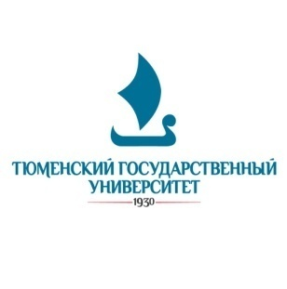  Tyumen State University | 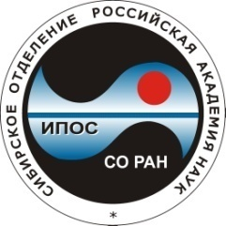  Institute of problems development of the North, SB RAS
MatveevaNataliaPetrovna (3452)455-106  nataliamatveeva1703@yandex.ru  ZelenkovAlexanderSergeyevich 8-919-957-86-35qvimen@hotmail.com  Kozlov Sergei Alexandrovich8-912-995-10-89  sergeikozloff@mail.ru | AdaevVladimir Nikolayevich(3452) 229-360  whitebird4@yandex.ru  RyaboginaNataliaEvgenyevna(3452)688-764  nataly.ryabogina@gmail.com  ChikunovaIrinaYuryevna(3452) 688-763chikki@mail.ru  YakimovArtemSergeyevich (3452) 688-737  Yakimov_Artem@mail.ru  SlepchenkoSergeyMichailovich(3452) 688-752  s_slepchenko@list.ru

form 1

In order to organise our scientific meeting, we start to collect preliminary information about potential participants, directions of the expected presentations to help us set up the provisional thematic sessions in the program. Participants are kindly filled the pre-registration form noting keywords by September 1st. Please address your pre-registration forms to the conference email: ecologia-2016@mail.ru
Participant information
Full name
Scientific degree, academic rank, position
Date of birth
Institution (full title)

Address

E-mail
Telephone number
Information about report
Author(s)

Section
Preliminarytitle
Form of presentation
(oral / poster)
Problematic topics
Biological anthropology | Archaeology |  | Ethnology | History
Dating / Isotopes | Stratigraphy |  | Paleobotany | Osteology
Paleopathology and paleoparazitologiya | Soils and soil geochemistry |  | Palaeohydrology | Cultural geography
Palaeolithic Age | Mesolithic / Neolithic Age |  | Bronze Age | Early Iron Age
Early Middle Ages | Late Middle Ages |  | Pleistocene | Holocene
Environmental reconstruction | Life-support systems |  | Land use | Adaptation of economy
Ancient diet | Biological adaptation of man |  | Practice of landscape  transformation | Space and place
Traditional ecological knowledge | Domestication |  | Ecological anthropology | Natural catastrophes

Please, tick keywords best describing the content of your presentation (any colour you like). If necessary, you can propose other keywords.

